Git Configuration on windows and Uses of Git as source control provider.

Git configuration/Installation

- Install Git Extensions, It would provide options to install MsysGit(git for windows) and KDiff(merege tool).

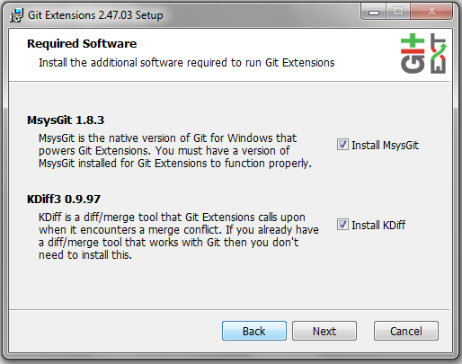

- During installation it would prompt GuI to install KDiff.Complete the installation.
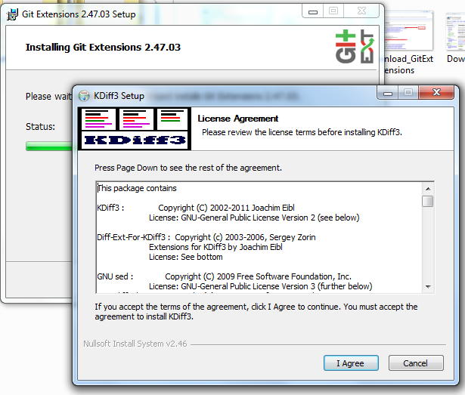

- Then it would also prompt to install msysGit. Complete the installation.
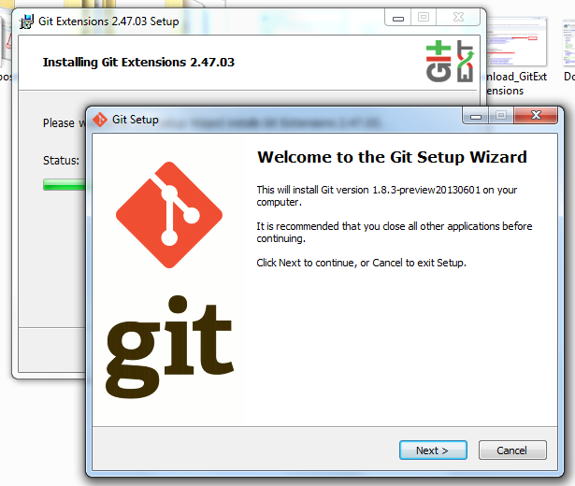

- Now check GitExtension Settings.

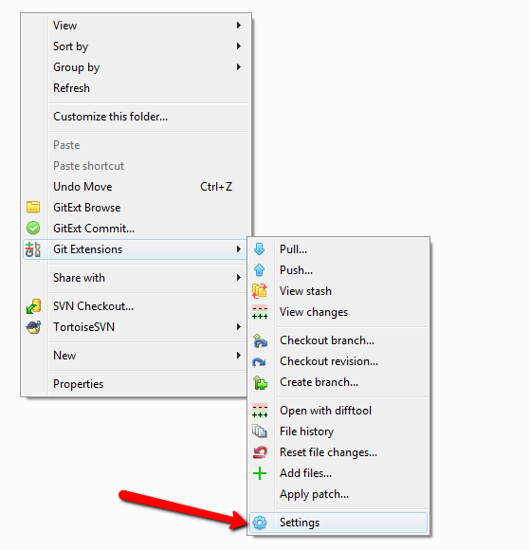

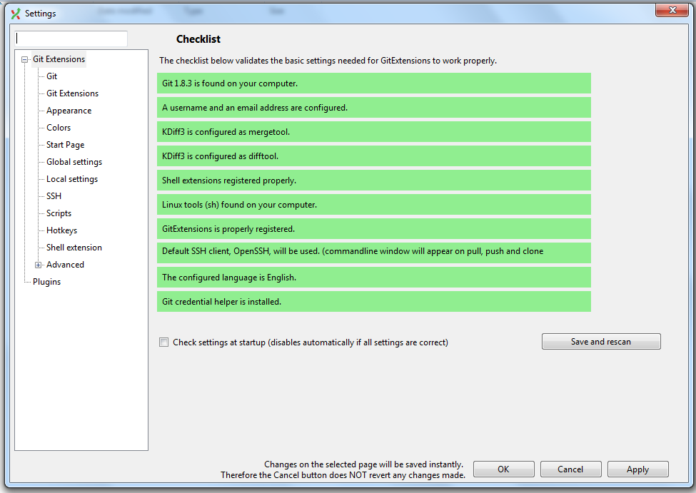

- If any of the settings in the above picture shown as red text with repair then fix these settings.

- Now set the Global Settings and Local Settings.
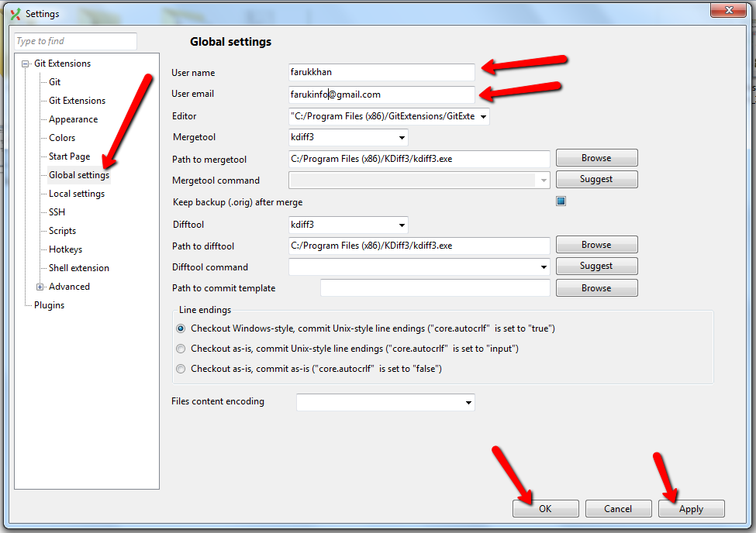

- Now install TortoiseGit.
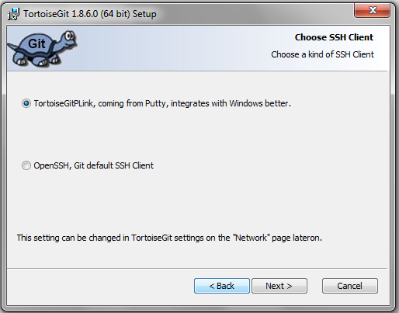

- Check TortoiseGit--→ Settings.

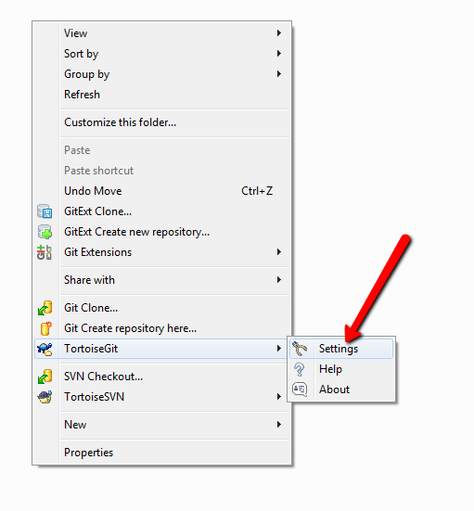

- Set Git credentials.
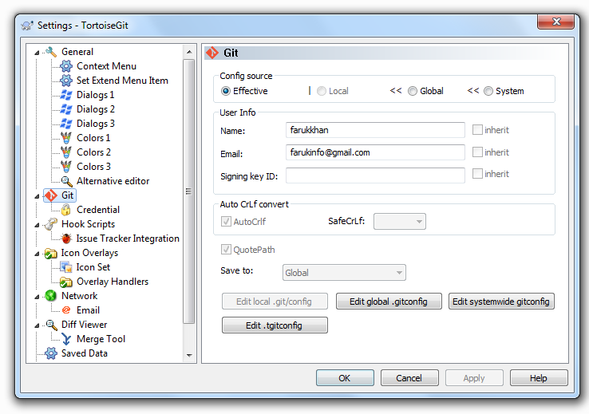

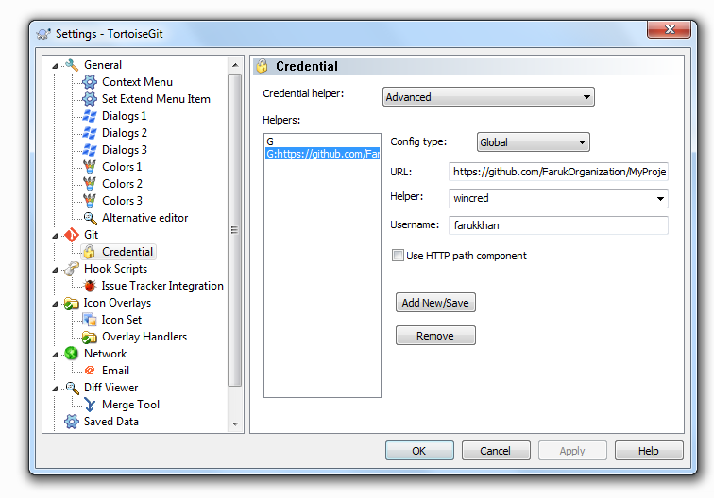

- Installation is completed. Now it is time to use Git as a source control provider.

Using Git as source control provider

- Get repository from remote repository. Right click on a directory location which wanted to make as working directory. Select Git Clone option from the context menu.
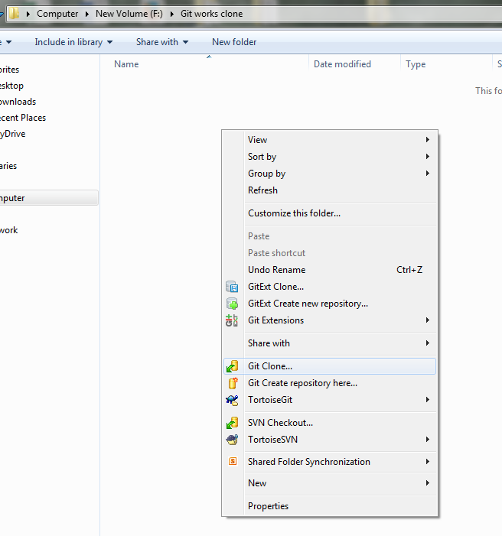

- To get project from remote repository, provide the URL into the URL field.
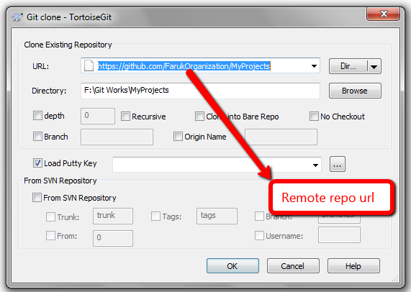

- Start downloading the remote repository.

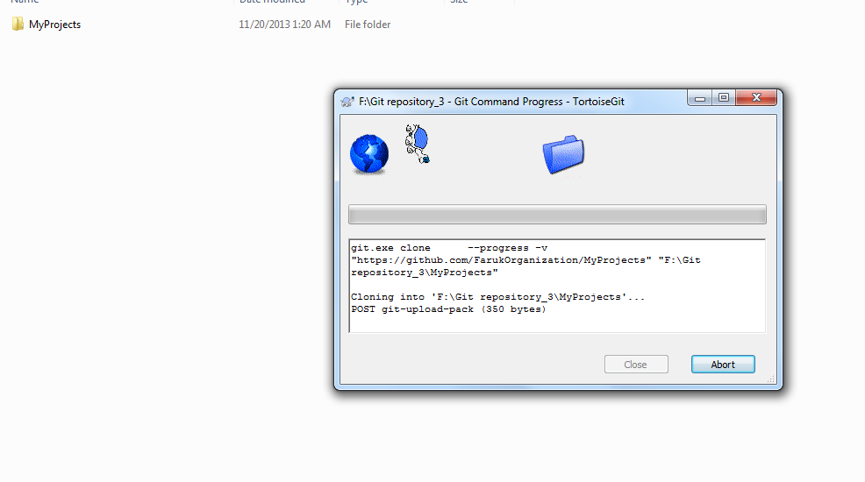

- Now open the project with visual studio. To work visual studio with git, another tool Git Source Control Provider is needed to install.
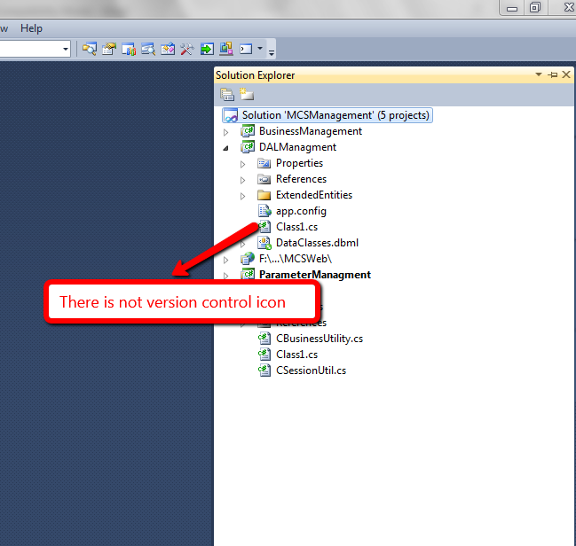
- Follow the steps provided in the picture to download and install Git Source Control Provider.
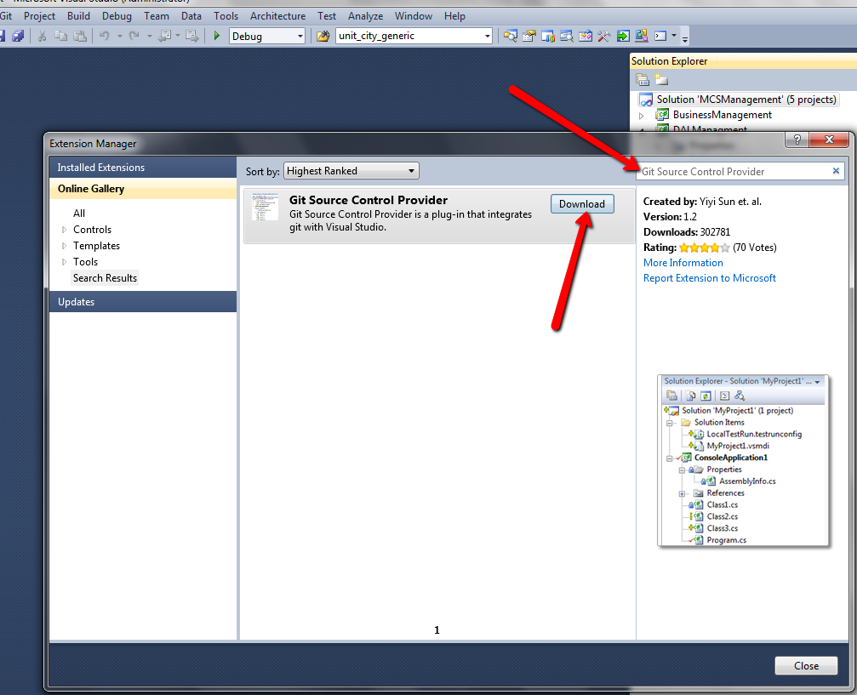

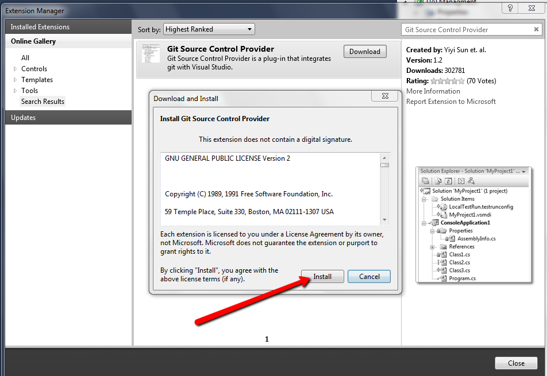

- After installation make Git Source Control Provider as default source control plug in.
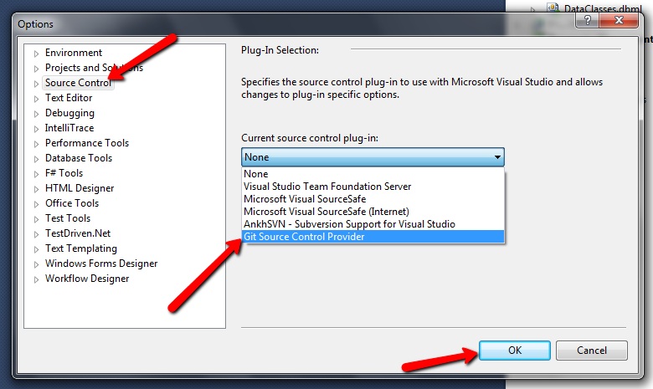

- Now the project is controllable from visual studio.
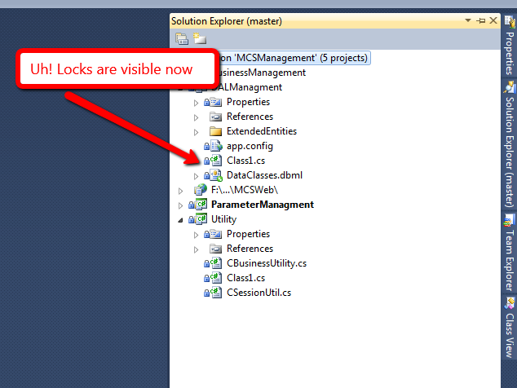

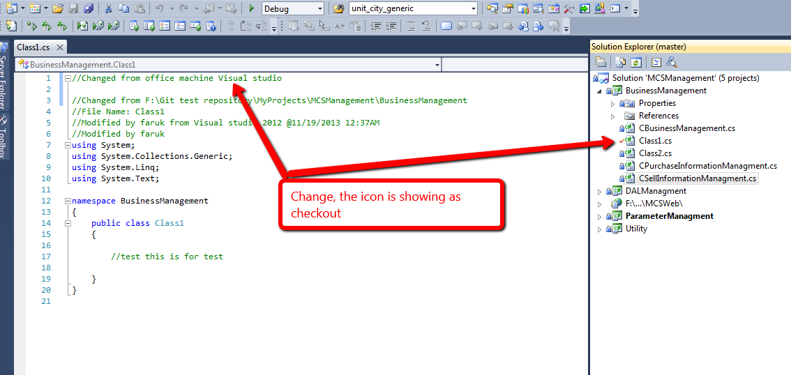
- Right click on project, context menu shows TortoiseGit and Git Extension related commands to control project.
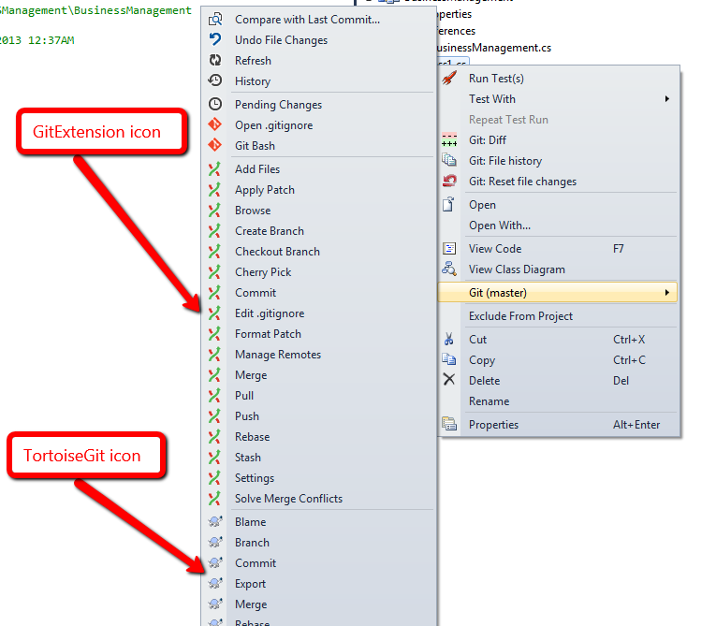

- To add local changes into local repository, use any of the Commits either from GitExtensions\TortoiseGit.
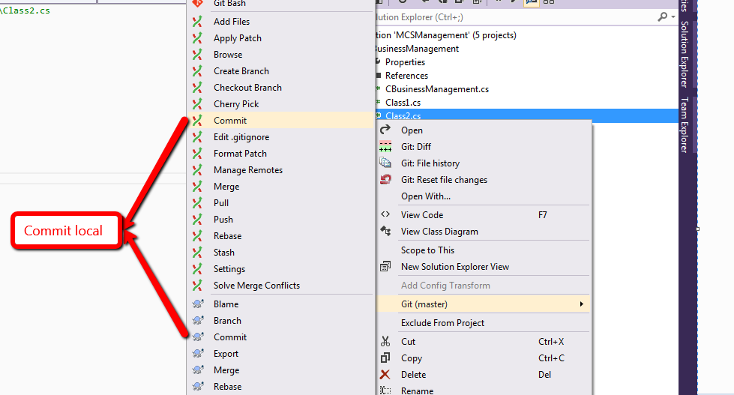

- To add local changes/local branches to Remote repository/Server, use Push command.
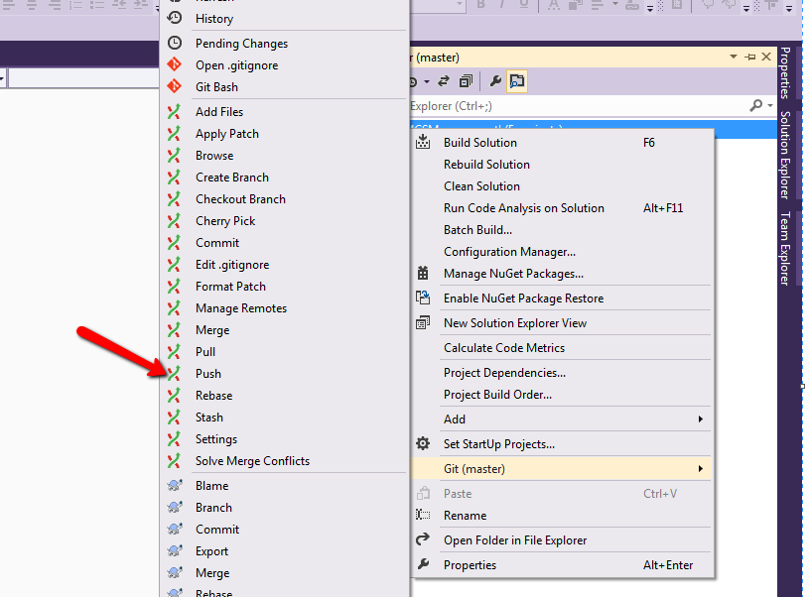

- After applying Push command a dialog opens asking the remote branch name, to which the local changes would be applied.
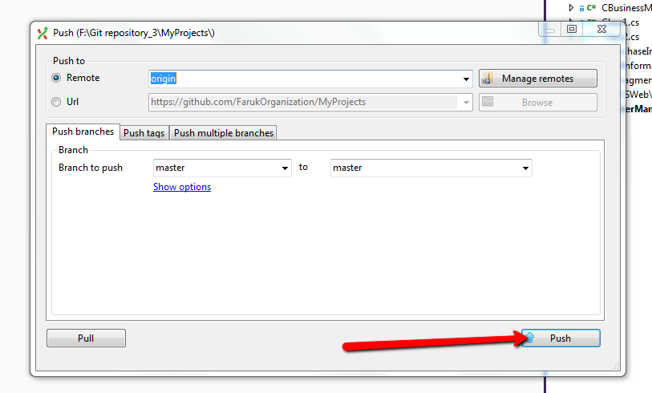

- To get latest from server (Merge local changes with server branch).
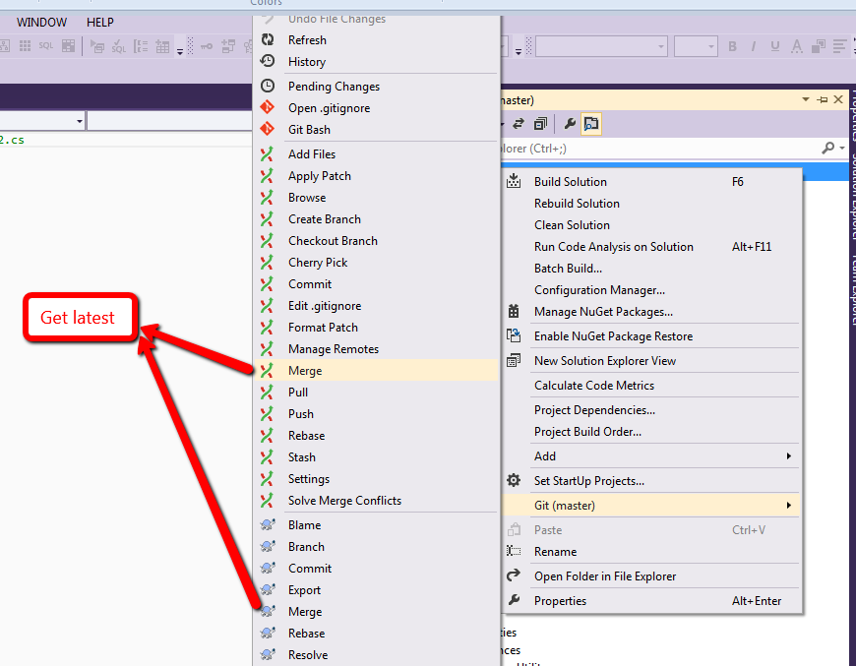

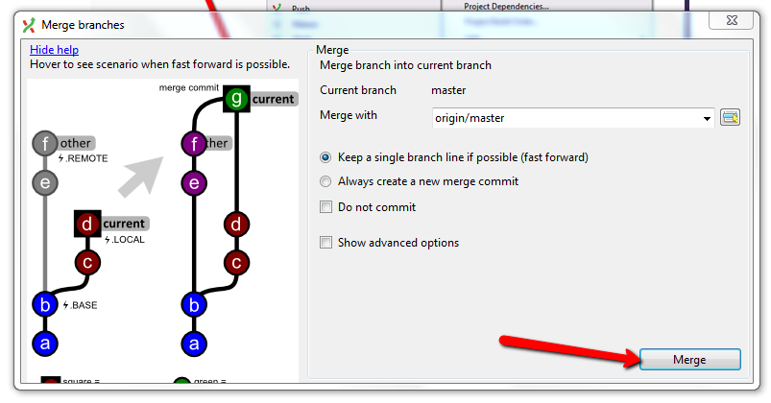
- Checkout Branch → Can be also used to take latest version from both local/Remote repository.

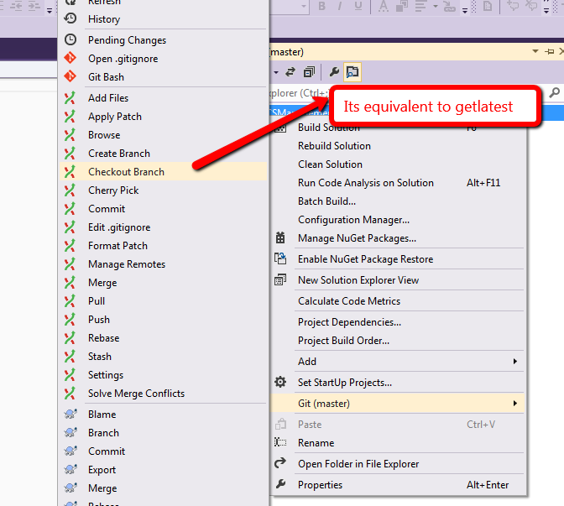

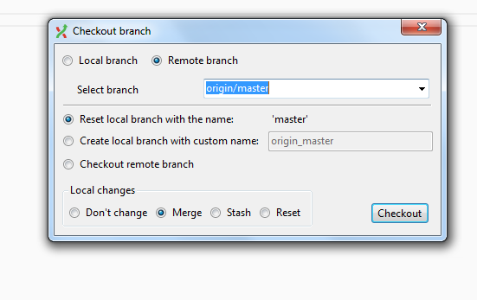

- Now suppose you worked on an issue, but want to commit and push it in a branch for future use.
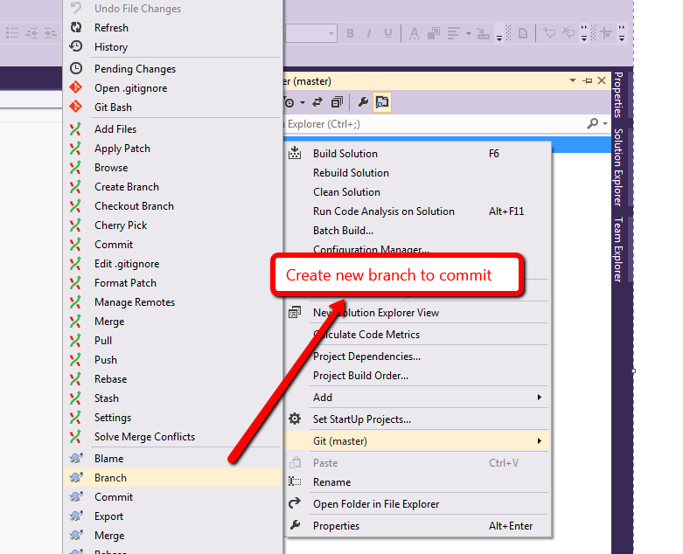

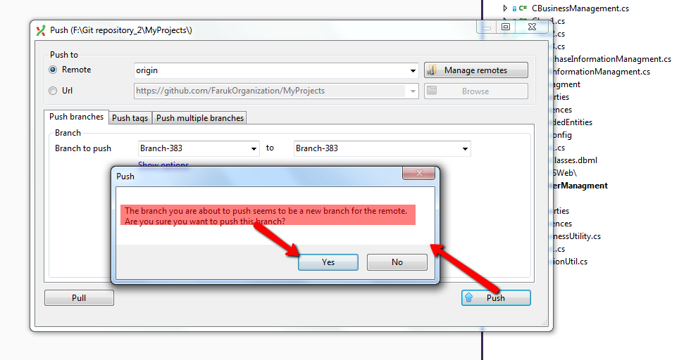

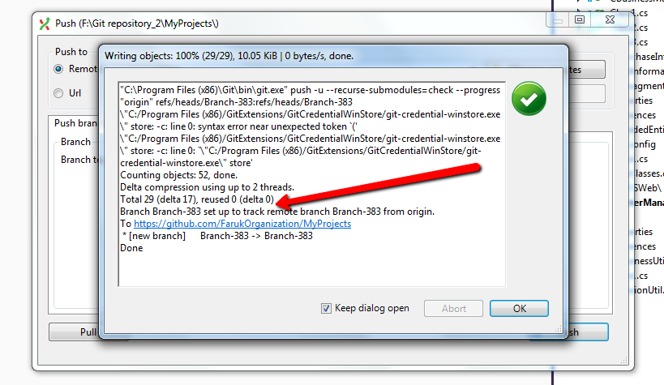

- After pushing you want to continue work on master.
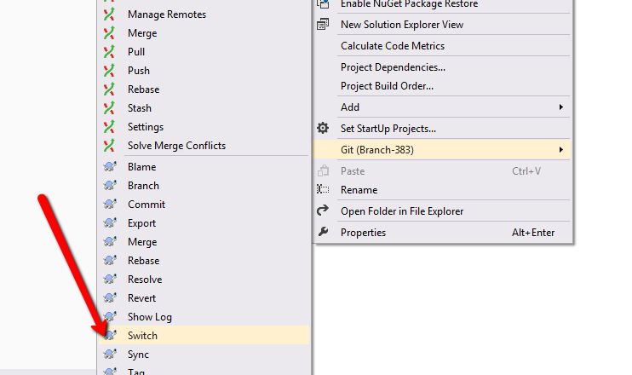

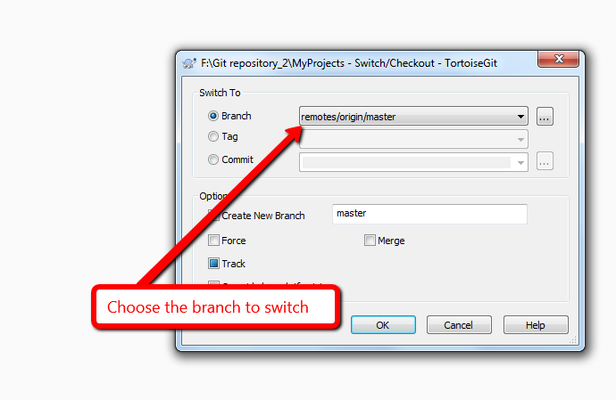

- Started working on master. Now decision taken to implement Issue-383. And move away the changes that you made on master. To move the changes use stash (stash is like a branch, it saves the changes in a separate place).

